- We expect the Bank of England's Monetary Policy Committee to hold Bank Rate at 3.75% at next week's meeting.
- The duration and severity of the energy price shock caused by the war in the Middle East is highly uncertain. So we think the divided committee will be wary about the risks of making a policy error and is likely to err on the side of caution for now.
- Should the energy shock prove short-lived, we still think there's a chance that the committee resumes its cutting cycle in April or June. But if the shock persists or expands, the MPC will be set for an extended pause.
The Bank of England's Monetary Policy Committee used February's meeting minutes and accompanying press conference to signal that an interest cut was highly likely at one of the next two meetings. But the war in the Middle East has changed the dynamic. Financial markets currently assess the chances of a March rate cut as close to zero, and that a cut in April is also looking unlikely without a quick resolution to the conflict. We agree and expect the MPC to vote decisively to keep Bank Rate at 3.75% at next week's meeting.
Although a wealth of economic data has been published since the February meeting, the most important question is how the economic fallout from the war is influencing the MPC's thinking. The conflict represents a new adverse supply shock for the UK, but there's considerable uncertainty surrounding its severity and duration. While the March meeting minutes will be the first opportunity for each member to set out how recent developments are shaping their respective outlooks, we suspect most will probably avoid making any strong statements about future interest rate decisions.
Chart 1: Oil and gas futures prices have risen significantly, particularly at the front end of the curve
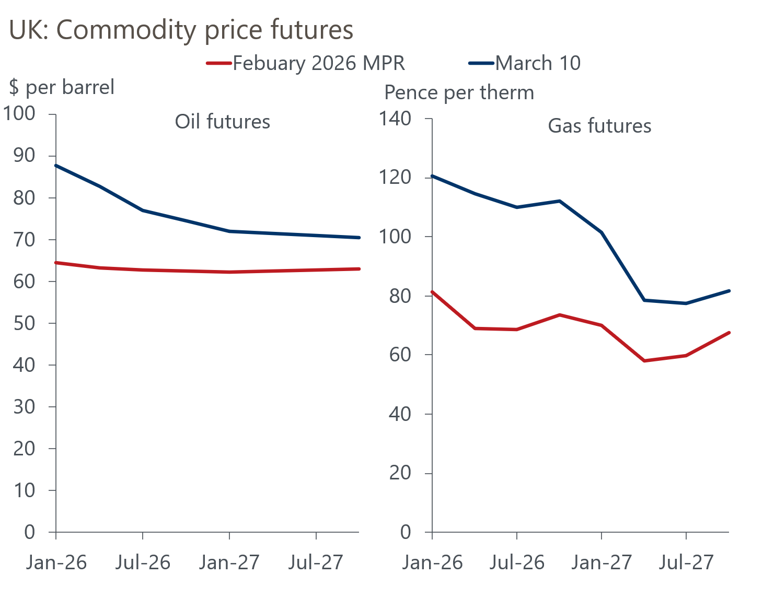
Sources: Haver Analytics

Higher oil and gas prices are a supply shock, but the likely impact on inflation is unclear
The UK inflation outlook was starting to brighten, but the conflict in the Middle East has thrown a spanner in the works. Oil and gas futures prices have shifted significantly higher over the past two weeks, particularly for shorter duration contracts, following Iranian attacks targeting production facilities and disruption to shipping supplies through the Strait of Hormuz (Chart 1).
Theres's already evidence that the pickup in oil prices is feeding through to UK petrol prices. For gas, Ofgem's quarterly energy price cap mechanism means the impact of the rise in European gas prices will be reflected in household energy bills from July. However, commodity prices are moving very quickly, and the length of time at which they stay elevated is unclear. Add in questions over if and when the government might eventually intervene to mitigate the financial hit to households, and the picture the BoE has of the likely path for inflation over the next year is currently very blurry.

The MPC will want to guard against the risk of additional inflation persistence
As we highlighted in a Research Briefing published last week, we don't think the old mantra that the MPC is likely to look through any inflationary effects of energy price shocks still applies. In part, this is because short- and longer-term UK inflation expectations are yet to fully normalise after the 2022-2023 surge in inflation (Chart 2). We think the MPC will want to lean against the risk that less well-anchored inflation expectations move higher in response to a new supply shock. This would help to lessen the likelihood of strong second-round effects forming that could keep inflation elevated for longer.
Chart 2: Short- and long-term inflation expectations remain well above pre-pandemic norms
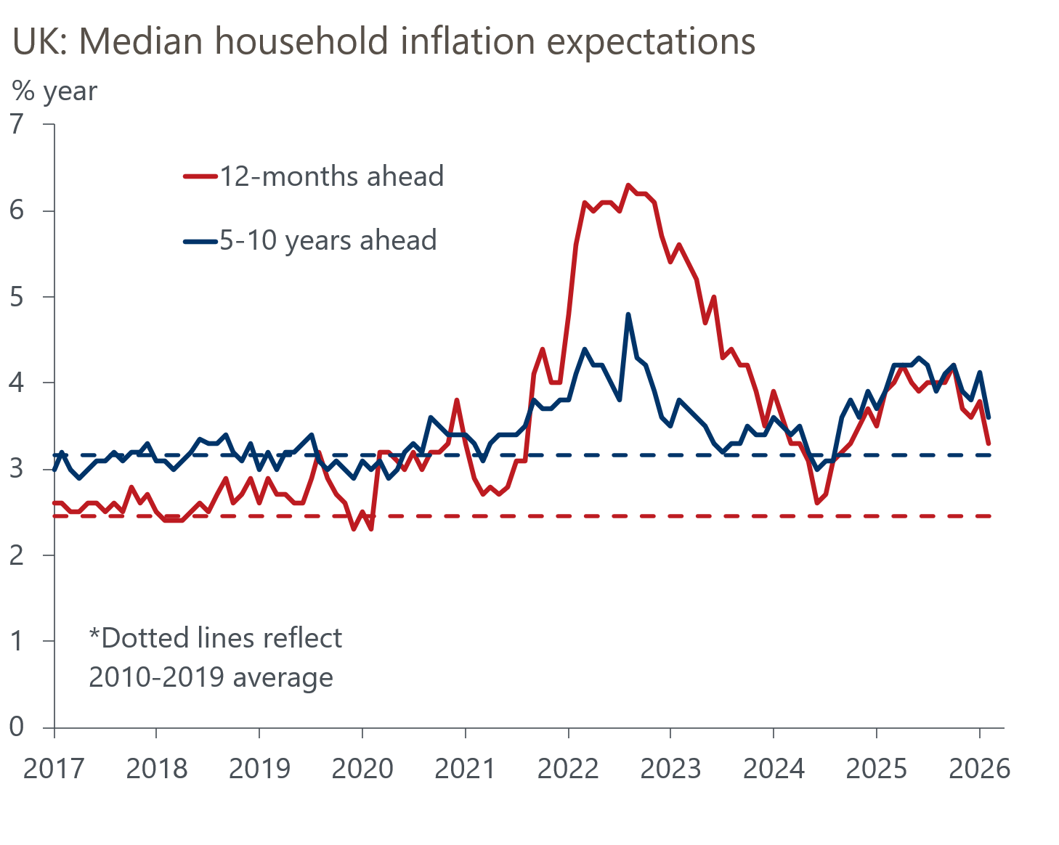
Sources: Citi/YouGov survey of inflation expectations
The committee has also been deeply divided for some time – Governor Andrew Bailey has cast the deciding vote at four of the past five meetings – which means the threshold to swing future decisions towards maintaining Bank Rate is low. The inflationary impulse from higher commodity prices has almost certainly now tipped the balance in favour of a hold.
Furthermore, with the duration and magnitude of the shock still very uncertain, a wide range of plausible inflation outcomes is possible. Therefore, we think the MPC will be very conscious about the risks of making major policy errors and the potential hit to credibility should the committee be forced into a policy reversal. This is likely to reinforce the committee's cautious approach to adjusting policy.

The MPC will likely remain in a 'wait and see' pattern
Against this backdrop, it's almost certain that the MPC will keep Bank Rate unchanged at 3.75% at the March meeting. If the shock proves short-lived and recent price rises fully reverse, we still think there's a reasonable chance that the MPC will resume its cutting cycle either in April or June. However, if the surge in energy prices persists or goes higher, the MPC will be set for an extended pause. Given that policy remains restrictive, we don't expect a majority of committee members to support hiking Bank Rate unless there is a substantial increase in inflation expectations.
We think MPC members will be reticent to use their individual paragraphs to offer any firm signals about how they are likely to vote at upcoming meetings. Still, we suspect a common theme in the minutes will be most members indicating that they favour a risk management approach to policymaking that leans against the risk of a renewed rise in inflation expectations, emphasises the importance of meeting the inflation target, and advocates the need for the committee to remain flexible to rapidly changing economic and geopolitical conditions.

